1.
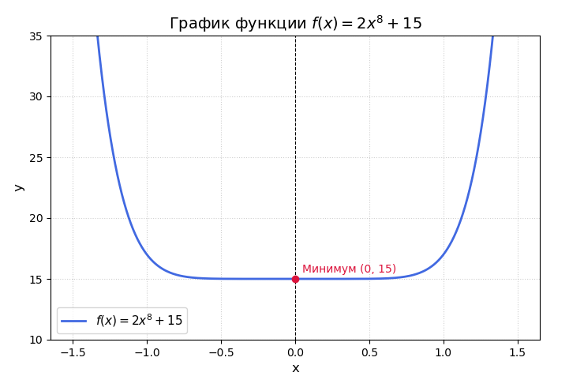
2.
import matplotlib.pyplot as plt
import numpy as np
import random as rnd

# 1. Задаем диапазон значений x
# Так как степень 8 растет очень быстро, возьмем небольшой интервал
x = np.linspace(0, 15, 16)

def F(x):
return -15 - 2*(x**8)

current_F_values = []
for i in x:
current_F_values.append(F(i))
# print(i, " ", F(i))

p = []
for j in current_F_values:
p.append(1-(j / sum(current_F_values)))
# print(j, ' ', 1 - j / sum(current_F_values))

s = sum(p)
for i in p:
i /= s
#print(i)

results = rnd.choices(current_F_values, weights=p, k=16)
parents = []
for i in results:
parents.append(current_F_values.index(i))

print(parents)

